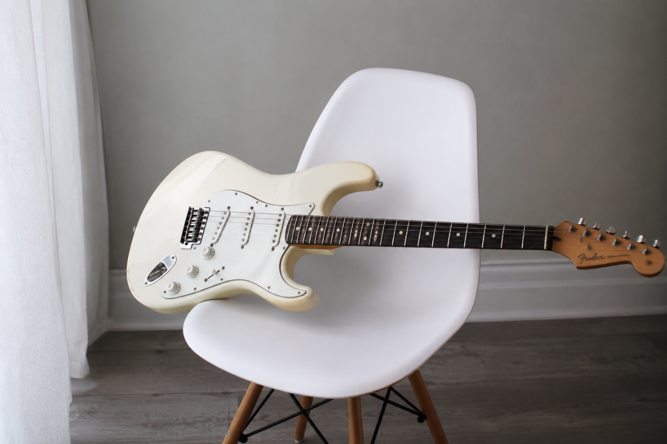

Is US design no longer protected in the EU?
Dirk Visser
It is possible that American designs are no longer protected by copyright in the EU. This is due to the so-called ‘term comparison rule’. This issue has resurfaced because a German court ruled in a default judgement that the shape of the Fender Stratocaster, designed in 1954, is protected by copyright in the EU.
In 2024, the Court of Justice of the EU ruled that American designs in the EU may not be excluded from copyright protection. This occurred in the Kwantum/Vitra case concerning a Vitra dining chair designed by Charles and Ray Eames and copied by Kwantum. The reason for this decision was that European copyright law does not permit discrimination on the basis of origin.
In the Kwantum/Vitra case, however, Kwantum had also invoked the so-called ‘term comparison’. This is the rule that if copyright has expired in the country of origin, it also expires in the country where protection is sought. This rule is set out in Section 42 of the Dutch Copyright Act and in Article 7(8) of the Berne Convention, but also in Article 7(1) of the Term of Protection Directive 2006/116/EC. This means that this ‘substantive reciprocity rule’ is not only permitted but is even mandatory under EU law.
In 2020, the Court of Appeal in The Hague ruled that it is ‘justifiable’ that, on the basis of this comparison of terms, ‘the term of protection may be reduced to the minimum required by the Berne Convention’ of 25 years after creation. In that case, the copyright on the dining chair produced in 1948 would have expired in 1973’. However, the Court of Appeal in The Hague ruled, without giving any reasons: ‘That approach is not, however, applicable law’.
Kwantum also appealed to the Supreme Court on this point, but the Supreme Court did not (yet) address it, as it first referred questions to the Court of Justice of the European Union, though not concerning this term comparison. Following the ruling of the Court of Justice of the European Union, the case was settled, meaning that the Supreme Court will no longer rule on this matter.
In his 2009 thesis, international private law expert Sierd J. Schaafsma described the failure to apply term comparison in cases where the country of origin offers no protection at all as a ‘distorted result’: “This does not seem to have been the drafters’ intention, so it can be argued that the lex loci protectionis may in this case reduce the term of protection to the mandatory minimum under the Convention.” [of 25 years after creation] (p. 313). Schaafsma reiterated this in the English version of his book from 2022 (para. 852). It is highly plausible that the European legislator did not intend this either with Article 7(1) of the Term of Protection Directive 2006/116/EC, meaning that limiting the term of protection to 25 years after creation is not merely permissible, but mandatory.
If that is the case, the Vitra dining chair has no longer been protected by copyright in the EU since 1973, and the Fender Stratocaster has no longer been protected since 1979.
[Image generated with ChatGPT].

Prof. dr. Dirk J.G. Visser is professor Intellectual Property Law at Leiden Law School and partner at Visser Schaap & Kreijger in Amsterdam. He is grateful for comments on an earlier draft by his partners Arnout Groen and Paul Kreijger. A Dutch version of this comment appeared on https://www.mr-online.nl/amerikaans-design-toch-niet-meer-beschermd-in-de-eu/

